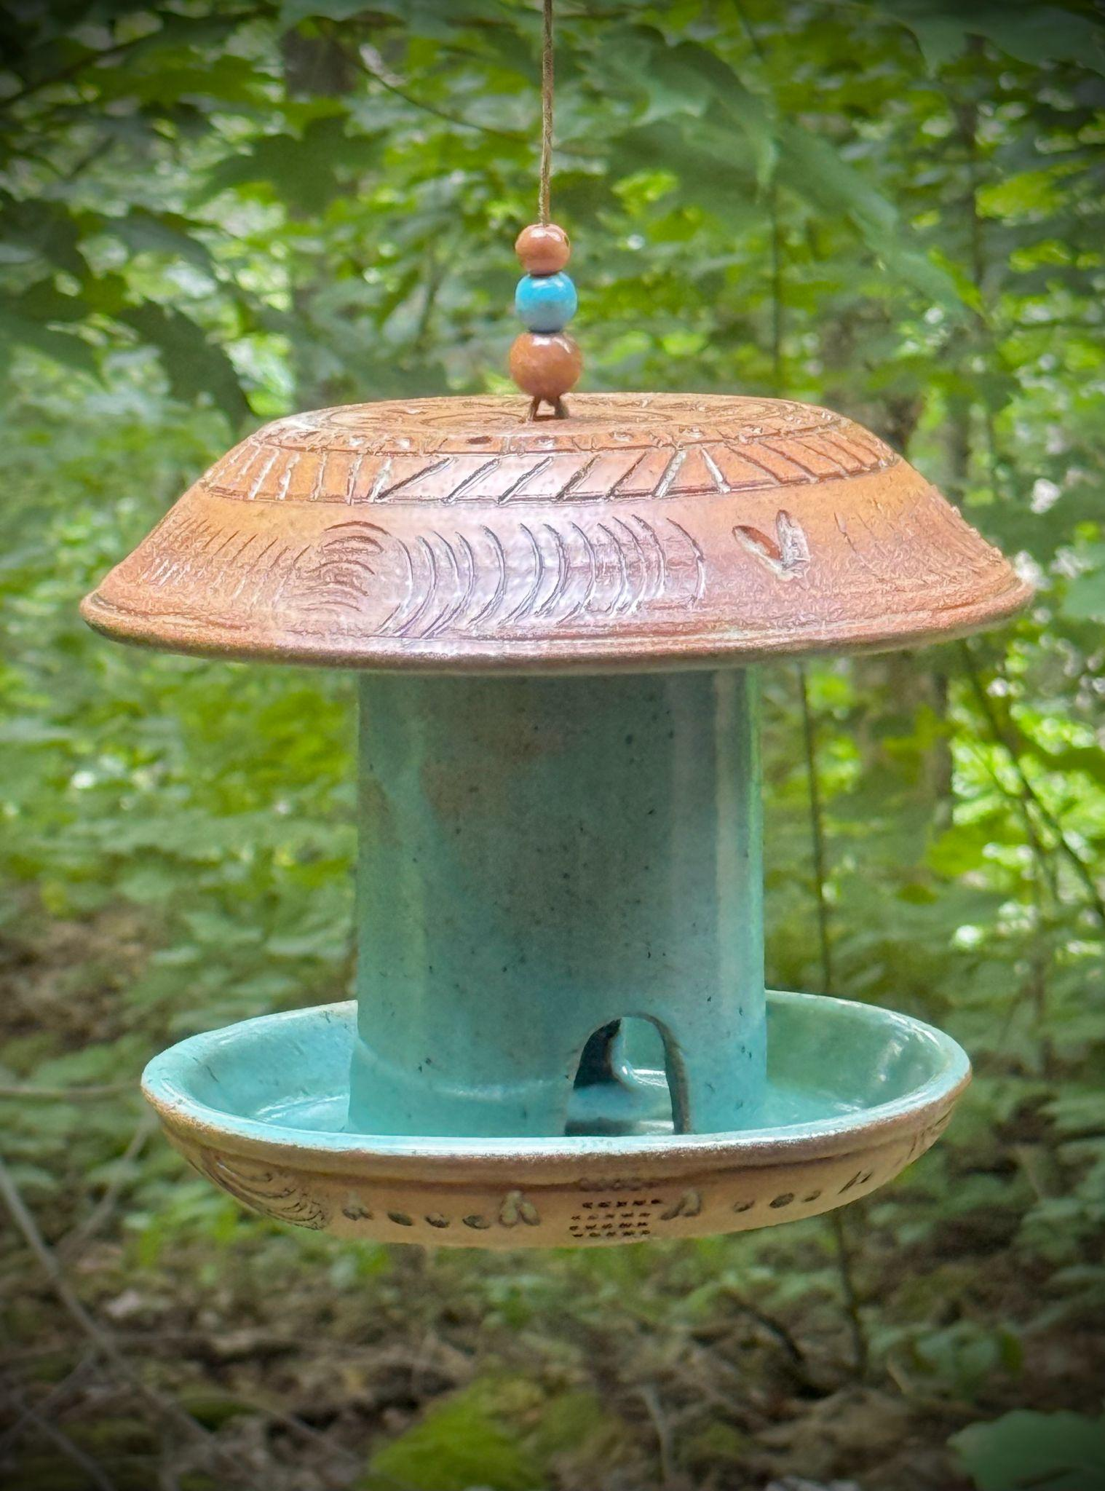
Artwork 1: The Woodland Table
Size: 25 cm
Price: $170

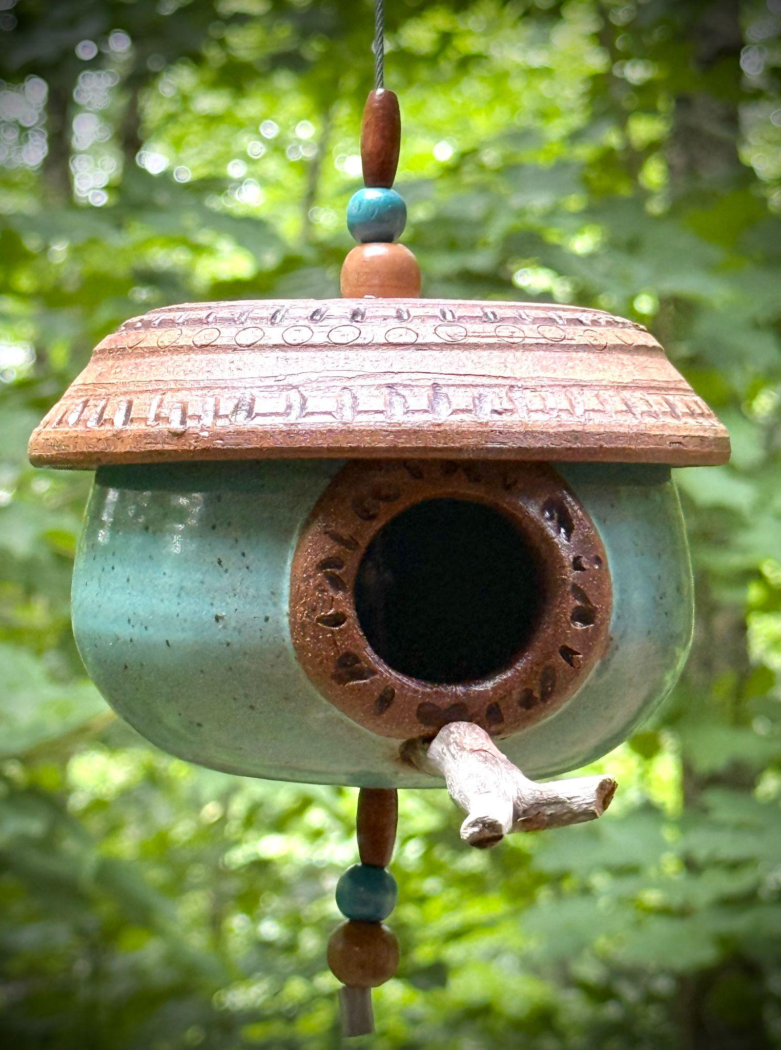
Artwork 2: The Woodland Womb
Size: 15 Cm
Price: $170

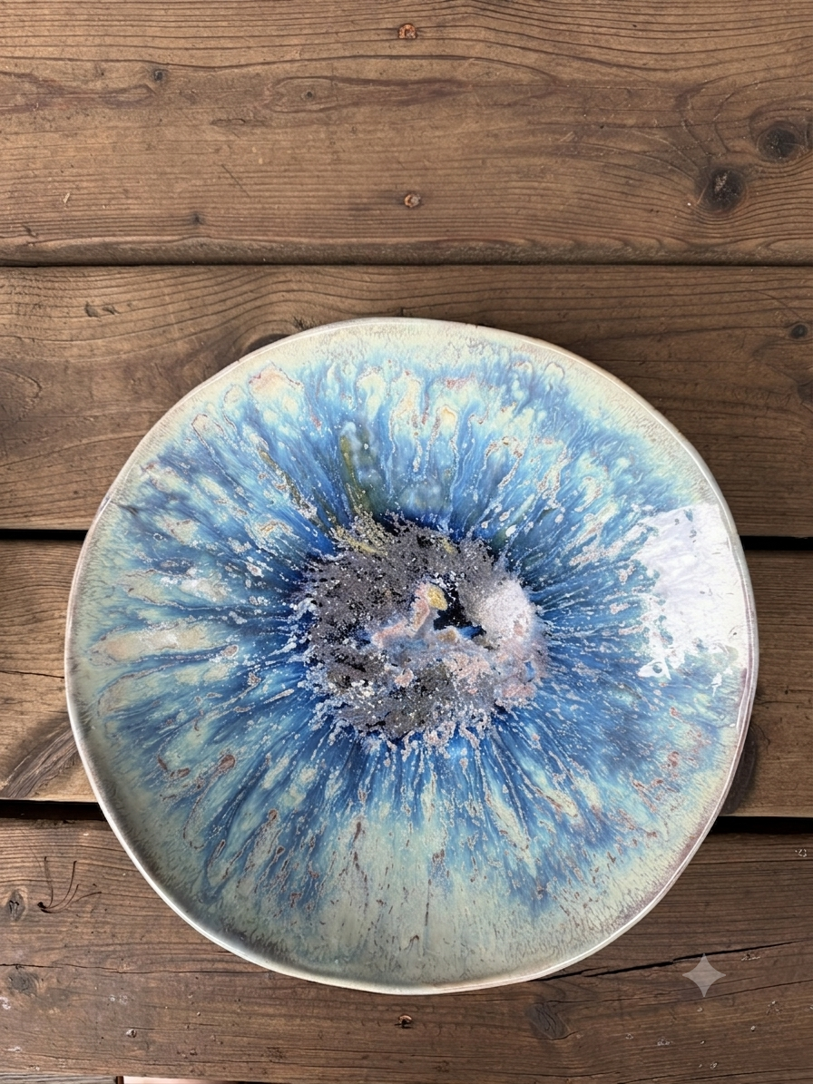
Artwork 3: Muskoka Water
Size: 30 cm
Price: $170

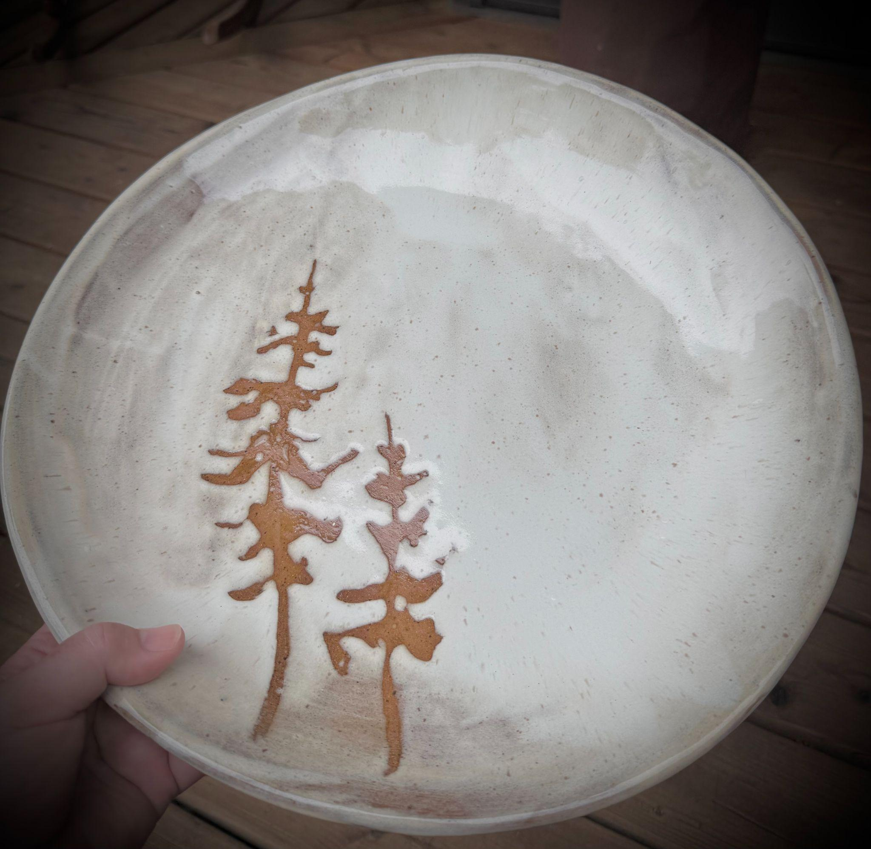
Artwork 4: Whispering Pines
Size: 40 cm
Price: $195

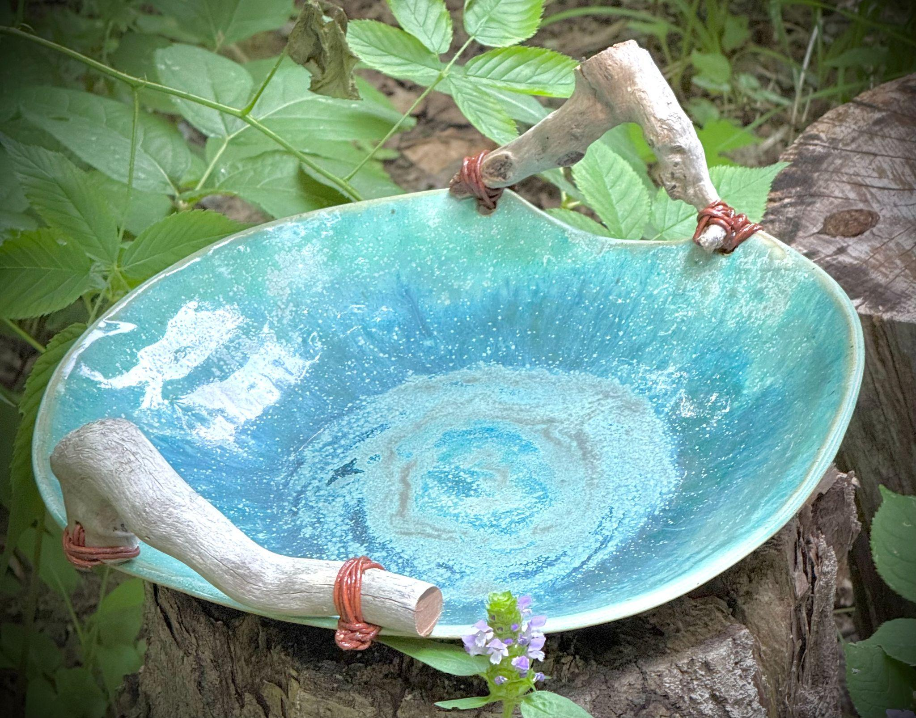
Artwork 5: Muskoka Shores
Size: 30 cm
Price: $195

